Kod html:

<!DOCTYPE html>

<html lang="pl">

<head>

    <meta *charset*="UTF-8">

    <meta *name*="viewport" *content*="width=device-width, initial-scale=1.0">

    <title>Css zaawansowany</title>

    <link *rel*="stylesheet" *href*="style.css">

</head>

<body>

    <div *class*="zad">

        <h1>Zadanie 1</h1>

        <div *class*="rotateResponsiveItem">

            Tak jest prosto

        </div>

    </div>

    <div *class*="zad">

        <h1>Zadanie 2</h1>

        <div *class*="rotateItem">

            Będę się kręcić

        </div>

    </div>

    <div *class*="zad">

        <h1>Zadanie 3</h1>

        <div *class*="skewItem">

            Będę się bujać

        </div>

    </div>

    <div *class*="zad">

        <h1>Zadanie 4</h1>

        <div *class*="allAnimationItem">

            Będę robić wszystko

        </div>

    </div>

</body>

</html>

Kod CSS:

\* {

    box-sizing: border-box;

    margin: 0;

    padding: 0;

}

body {

    min-height: 100%;

    width: 100%;

    font-family: 'Roboto', sans-serif;

    background-color: #f5f6fa;

    text-align: center;

}

div {

    padding: 40px;

    margin: auto;

}

*.zad* {

    border: 1px solid black;

}

*/\* Zad 1 \*/*

*.rotateResponsiveItem* {

    margin-top: 100px;

    margin-bottom: 100px;

    background-color: deepskyblue;

    width: 300px;

    height: 300px;

}

@media only screen and (min-width: 200px) {

*.rotateResponsiveItem* {

        transform: rotate(110deg);

    }

}

@media only screen and (min-width: 400px) {

*.rotateResponsiveItem* {

        transform: rotate(90deg);

    }

}

@media only screen and (min-width: 600px) {

*.rotateResponsiveItem* {

        transform: rotate(70deg);

    }

}

@media only screen and (min-width: 800px) {

*.rotateResponsiveItem* {

        transform: rotate(50deg);

    }

}

@media only screen and (min-width: 1000px) {

*.rotateResponsiveItem* {

        transform: rotate(30deg);

    }

}

@media only screen and (min-width: 1200px) {

*.rotateResponsiveItem* {

        transform: rotate(10deg);

    }

}

@media only screen and (min-width: 1200px) {

*.rotateResponsiveItem* {

        transform: rotate(0deg);

    }

}

*/\* Zad 2 \*/*

*.rotateItem* {

    margin-top: 100px;

    margin-bottom: 100px;

    width: 300px;

    height: 300px;

    background-color: #39db34;

    animation: rotateAnimation 10s linear infinite;

}

@keyframes rotateAnimation {

    from {

        transform: rotate(0deg);

    }

    to {

        transform: rotate(360deg);

    }

}

*/\* Zad 3 \*/*

*.skewItem* {

    margin-top: 100px;

    margin-bottom: 100px;

    width: 300px;

    height: 300px;

    background-color: #e74c3c;

    animation: skewAnimation 2s linear infinite alternate;

}

@keyframes skewAnimation {

    from {

        transform: skewX(0deg);

    }

    to {

        transform: skewX(30deg);

    }

}

*/\* Zad4 \*/*

*.allAnimationItem* {

    margin-top: 100px;

    margin-bottom: 100px;

    width: 300px;

    height: 300px;

    background-color: #e4e73c;

}

@media only screen and (min-width: 400px) {

*.allAnimationItem* {

        animation: skewAnimation 5s linear infinite alternate;

    }

}

@media only screen and (min-width: 700px) {

*.allAnimationItem* {

        animation: rotateAnimation 10s linear infinite;

    }

}

@media only screen and (min-width: 1000px) {

*.allAnimationItem* {

        animation: transformAnimationX 5s linear infinite;

    }

}

@media only screen and (min-width: 1500px) {

*.allAnimationItem* {

        animation: transformAnimationY 5s linear infinite;

    }

}

@keyframes transformAnimationX {

    from {

        transform: scaleX(1);

    }

    to {

        transform: scaleX(-1);

    }

}

@keyframes transformAnimationY {

    from {

        transform: scaleY(1);

    }

    to {

        transform: scaleY(-1);

    }

}

Screen:

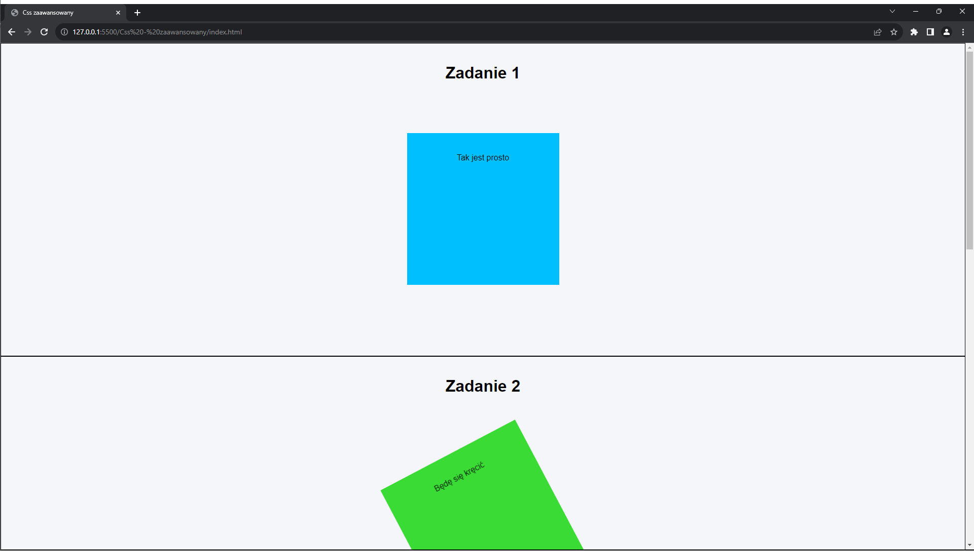

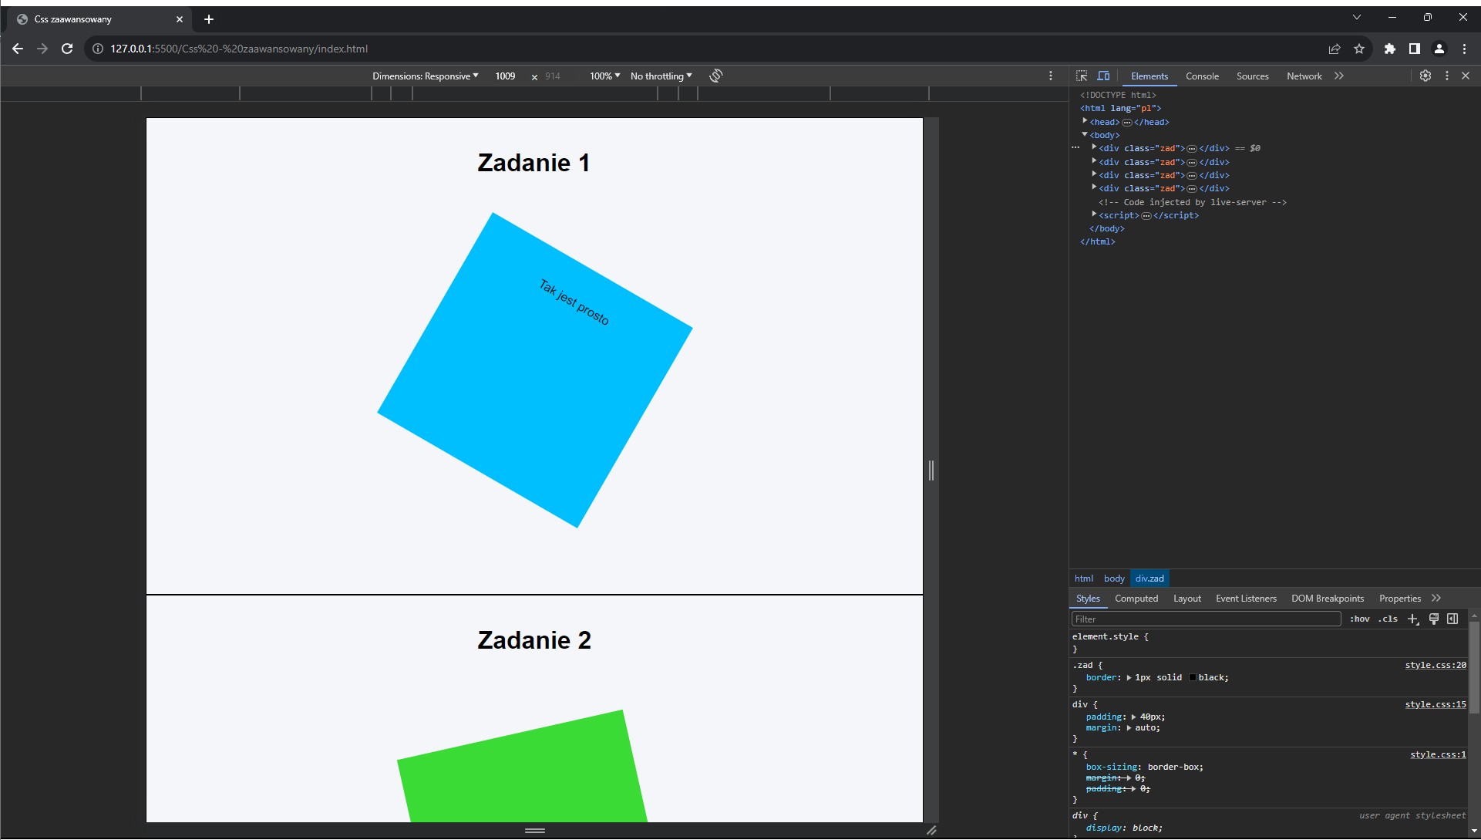

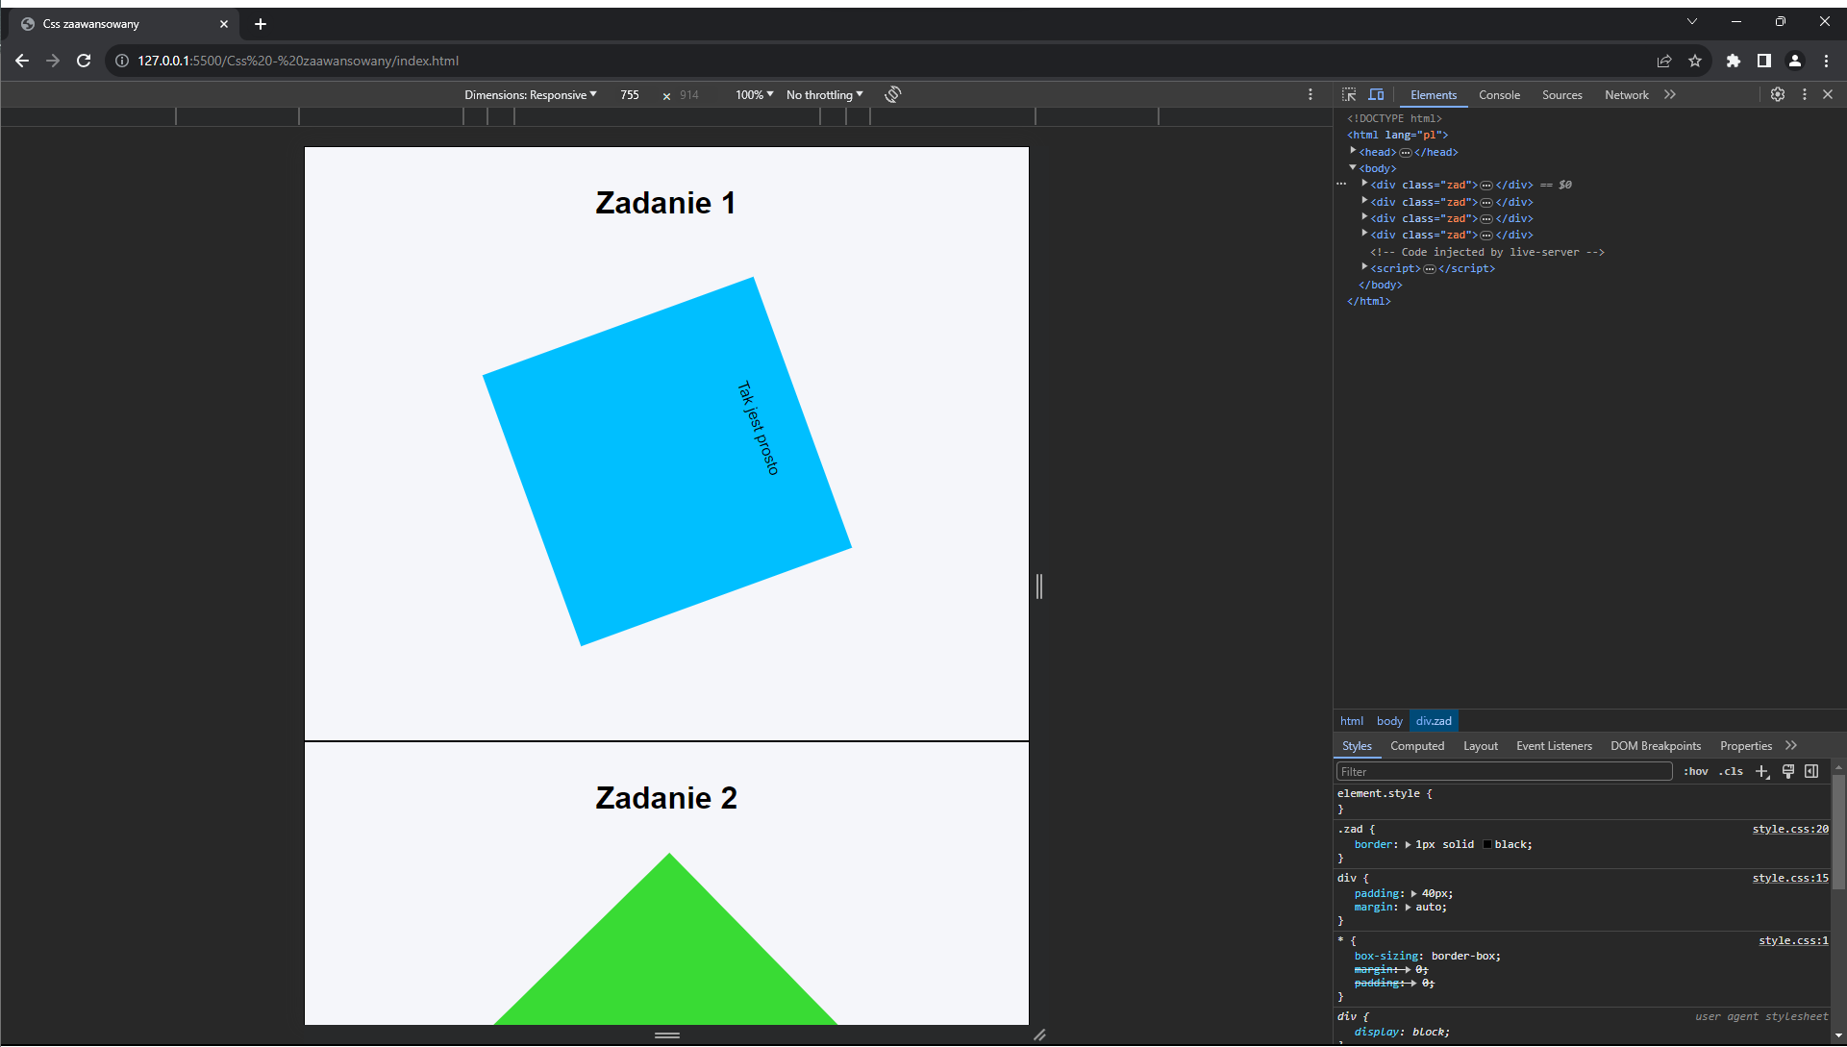

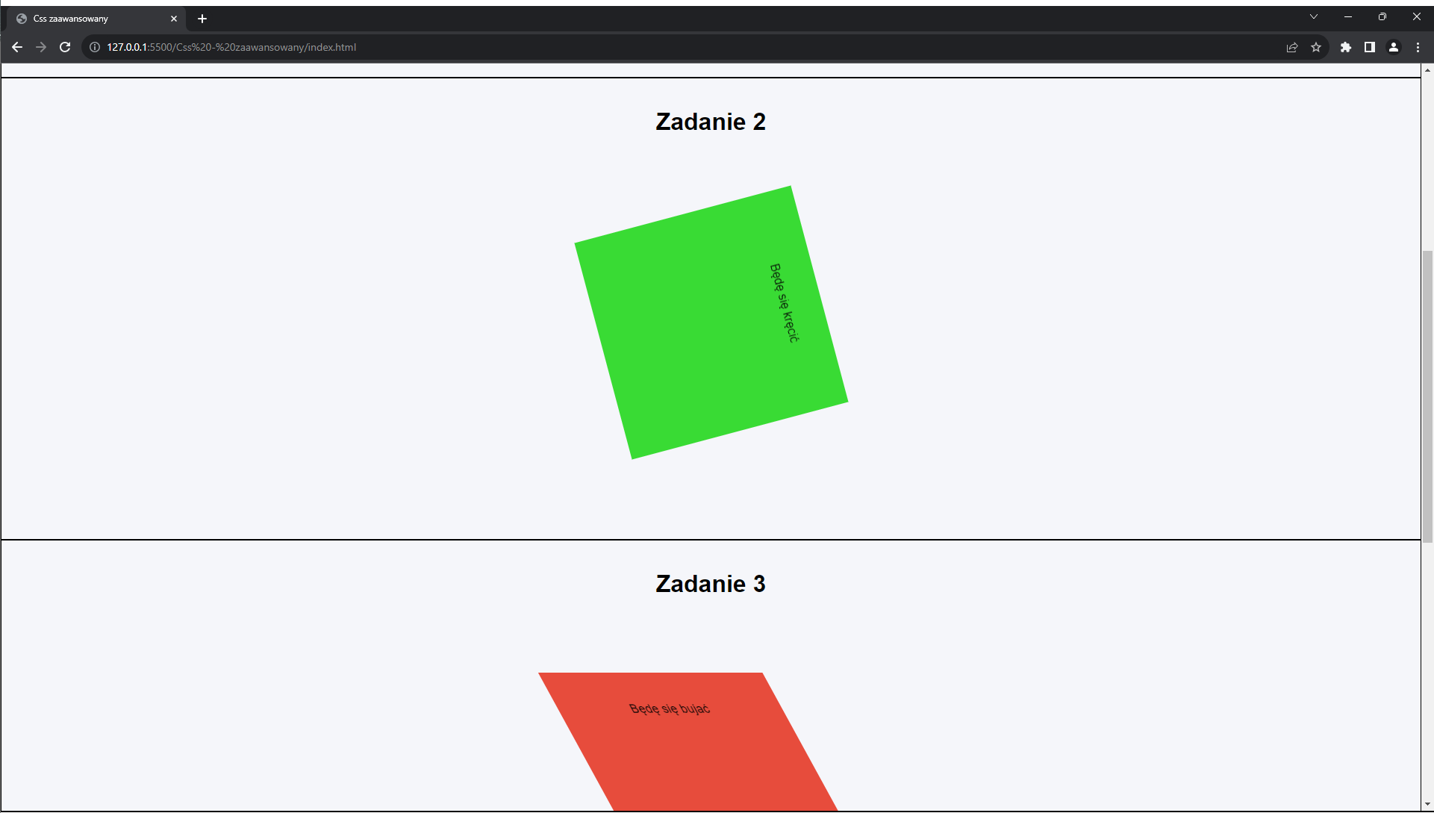

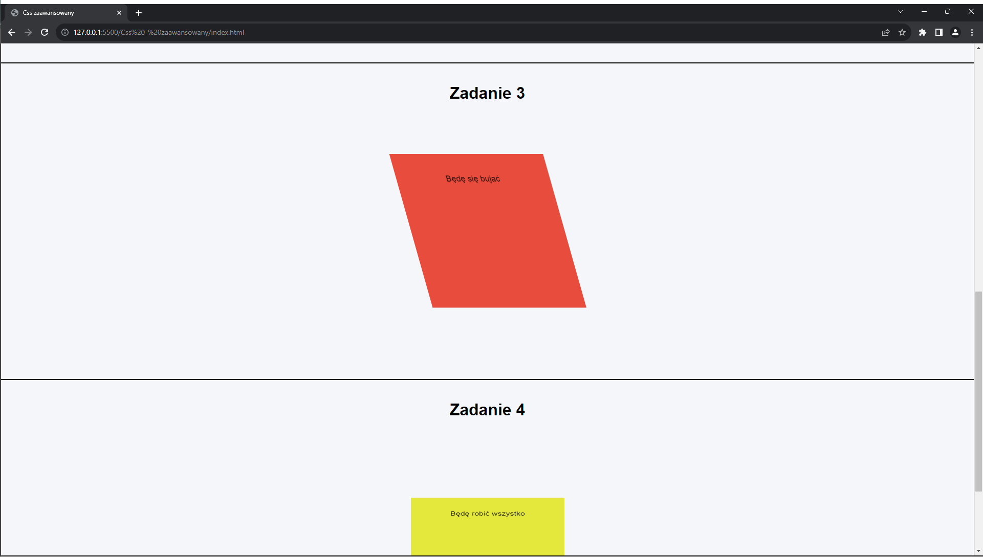

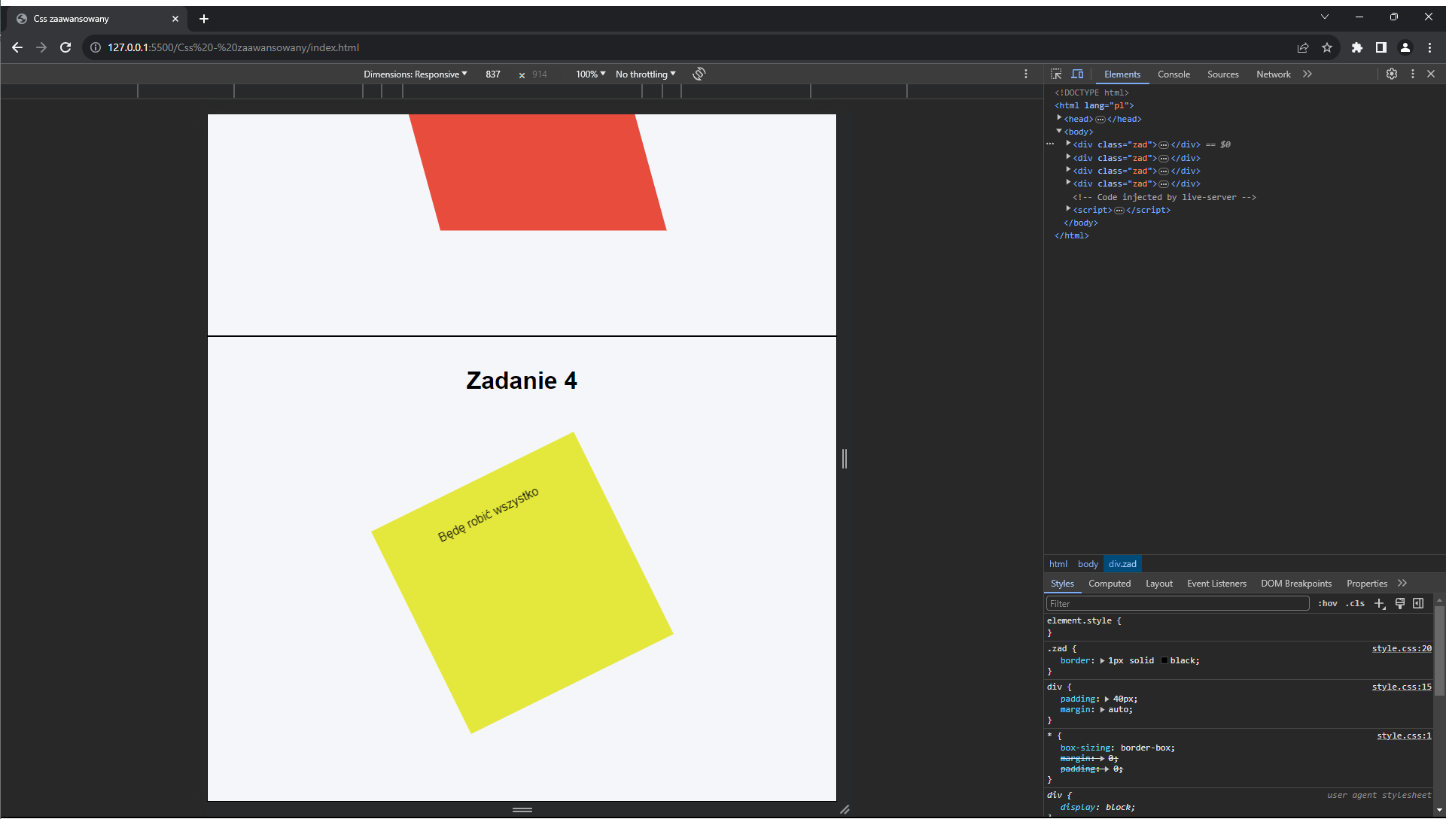

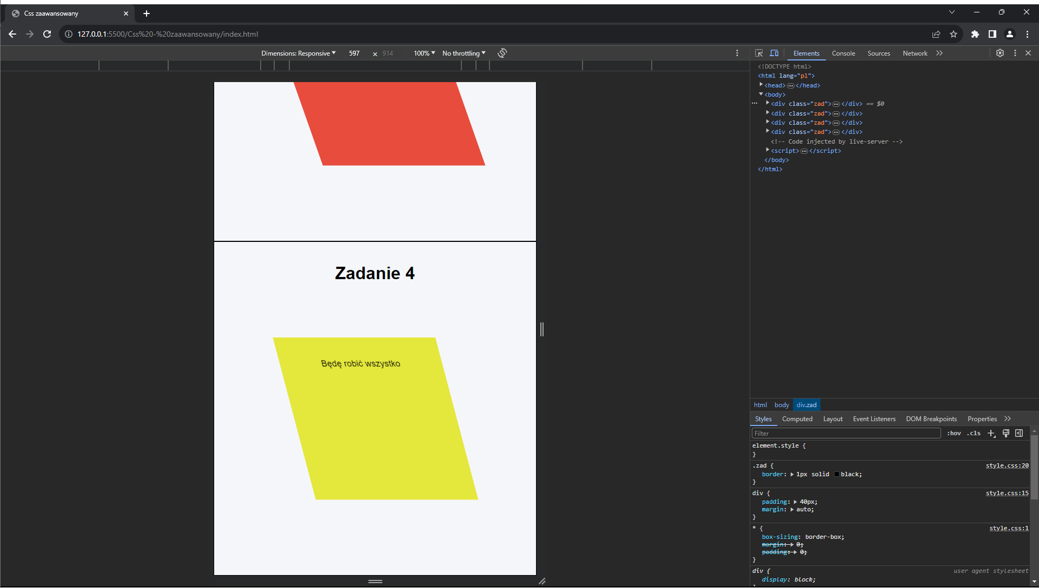

Link do repozytorium: <https://github.com/Vneder/Projektowanie-i-tworzenie-stron/tree/main/Css%20-%20zaawansowany>

*Łukasz Woźniakowski 17501*